Wrike



1. **Website**: [www.wrike.com](http://www.wrike.com)
2. **Năm thành lập**: The company was founded in 2006 by entrepreneur Andrew Filev, and currently has offices in San Jose, San Diego, and Dublin, Ireland.
3. **Miễn phí/không miễn phí**: Has both free + pricing plans

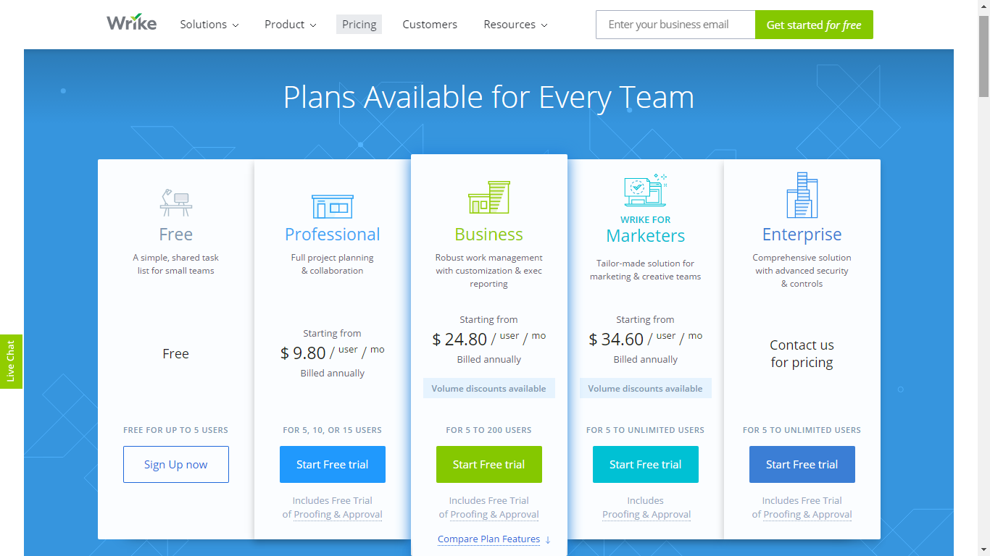

1. **Có app di động không**: Yes (Android, iOS)
2. **Có hỗ trợ các dịch vụ bên thứ 3 không:**

Third party integration

* Adobe Creative Cloud
* GitHub
* Google Drive
* Google Chrome extension
* Email
* Dropbox
* Box
* MS Excel
* MS Project

1. **Các tính năng hỗ trợ:**

* Work Management
* Gantt Chart
* Personal Dashboard
* Document Version Control
* Time & Budget tracking
* Project & Team Reporting

1. **Các khách hàng nổi tiếng sử dụng:**

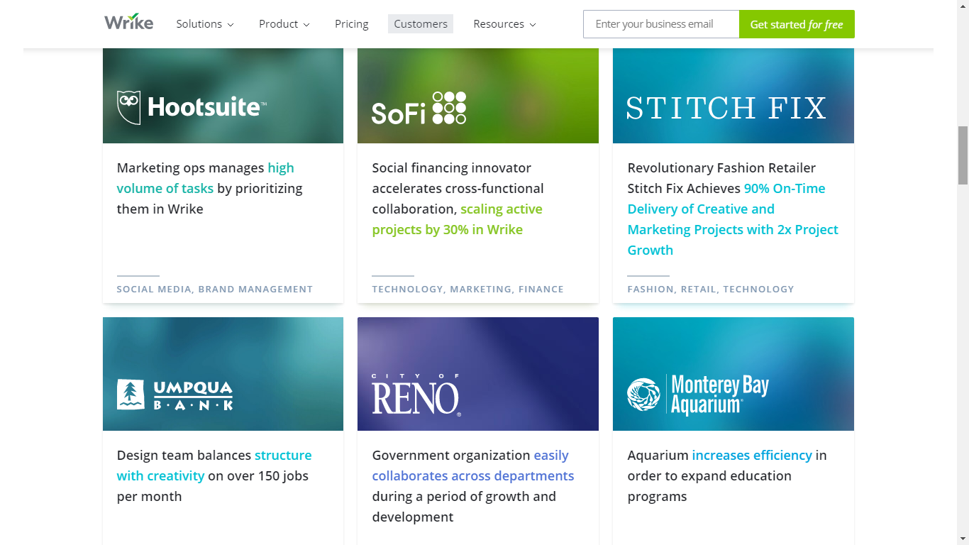

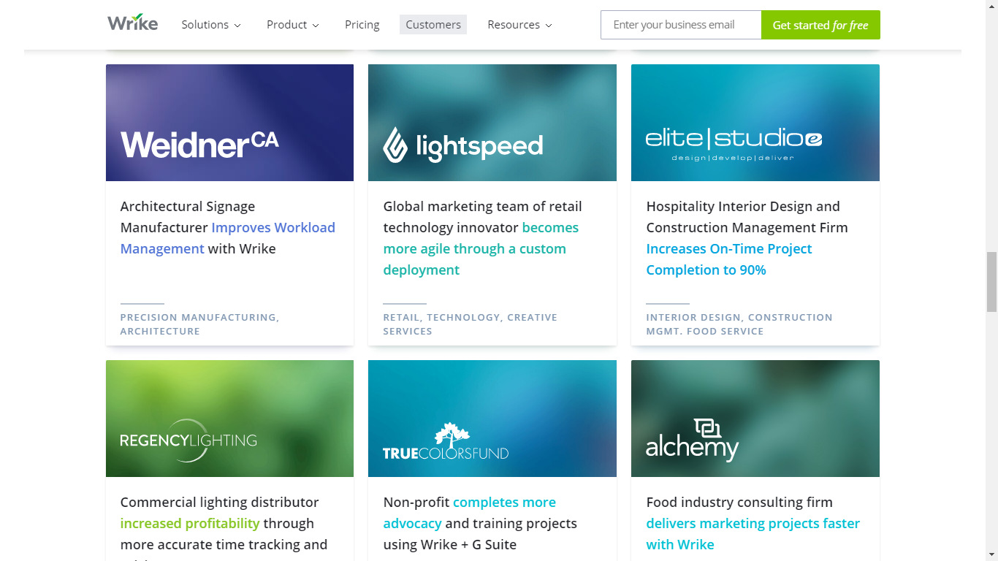

1. **Các giải thưởng (nếu có):**

* 2009 - *Red Herring*'s Top 100 Global Company Award[[16]](https://en.wikipedia.org/wiki/Wrike#cite_note-Crunch-16)
* 2015 - Listed in by Deloitte’s 2015 Technology Fast 500TM Ranking[[17]](https://en.wikipedia.org/wiki/Wrike#cite_note-17)
* 2015 - Named one of the "Best Places to Work" by *San Francisco Business Times/Silicon Valley Business Journal*[[18]](https://en.wikipedia.org/wiki/Wrike#cite_note-BIZ-18)